WEEK 5
AUTOMATION AND INTEGRATION OF SQL PROCESSES
Virtual Retail Database | PostgreSQL Implementation Guide
SQL Developer Internship — Final Week

Prepared by: Vipul Janardan Patil
Submission date: 08-11-26

1. Executive Summary
This report presents an automation design for the virtual retail database developed across the internship. It builds on the retail entities documented in the earlier data-modeling work: customers, products, warehouses, inventory, orders and order_items. The implementation package adds a transaction-safe sale procedure, an inventory trigger that records stock movements and maintains low-stock alerts, scheduled maintenance procedures for daily inventory snapshots and historical order archiving, and an automation log. A metrics view defines inventory turnover and stock cover days using explicit business formulas.
The main design objective is to move repetitive operational rules into controlled database workflows while preserving data integrity. A sale is processed as one atomic PostgreSQL CALL statement. Inventory is locked before stock validation to reduce overselling under concurrent requests. Trigger work is limited to inventory changes. Archiving is copy-only by default so historical source rows are not deleted before retention and recovery requirements are approved.
The SQL scripts and deterministic demonstration fixtures are included in the companion repository. This report distinguishes designed behavior and expected test outcomes from measured runtime evidence. No live internship database connection was available during document generation; therefore actual execution time, live row counts, query plans and screenshots must be captured by running the included harness against the target PostgreSQL database.

2. Scope, Platform and Existing Schema
Platform: PostgreSQL 14 or later. Schema: retail. The earlier modeling report documents customers(customer_id), products(product_id, sku, product_name, current_price), warehouses(warehouse_id), inventory(product_id, warehouse_id, quantity_on_hand), orders(order_id, customer_id, order_date, order_status), and order_items(order_item_id, order_id, product_id, quantity, unit_price). The automation migration adds products.unit_cost and inventory.reorder_level, then creates supporting tables.
The earlier data-modeling document describes a proposed design rather than proof that all tables are deployed. The bootstrap script creates compatible base tables when absent, but CREATE TABLE IF NOT EXISTS does not reconcile an existing table with a different schema. Review the live DDL and take a backup before running migrations.
Component | Purpose | Operational trigger
sp_process_sale | Validate and persist a single-product sale; decrement inventory | Checkout request
Inventory trigger | Write movement history; open/update or resolve low-stock alert | Inventory quantity UPDATE
sp_capture_daily_inventory | Capture daily on-hand stock and cost snapshot | Daily schedule
sp_archive_old_orders | Copy older orders and lines to archive tables | Monthly schedule
automation_log | Track scheduled process status, counts and errors | Each scheduled execution

3. Requirements and Business Rules
- Only active products and existing customers can be sold.
- Requested quantity must be a positive integer.
- Stock must be available at the selected warehouse; negative stock is prohibited.
- One order item stores the purchase-time unit price so later catalog price changes do not rewrite sales history.
- An inventory row is locked FOR UPDATE before checking and decrementing stock.
- At most one OPEN low-stock alert is maintained per product and warehouse.
- Replenishment above the reorder threshold resolves the current open alert.
- Archive jobs are idempotent and non-destructive; source data remains available.
- Metrics include paid/completed orders only and must state their time window and valuation assumptions.

4. Architecture and Workflow
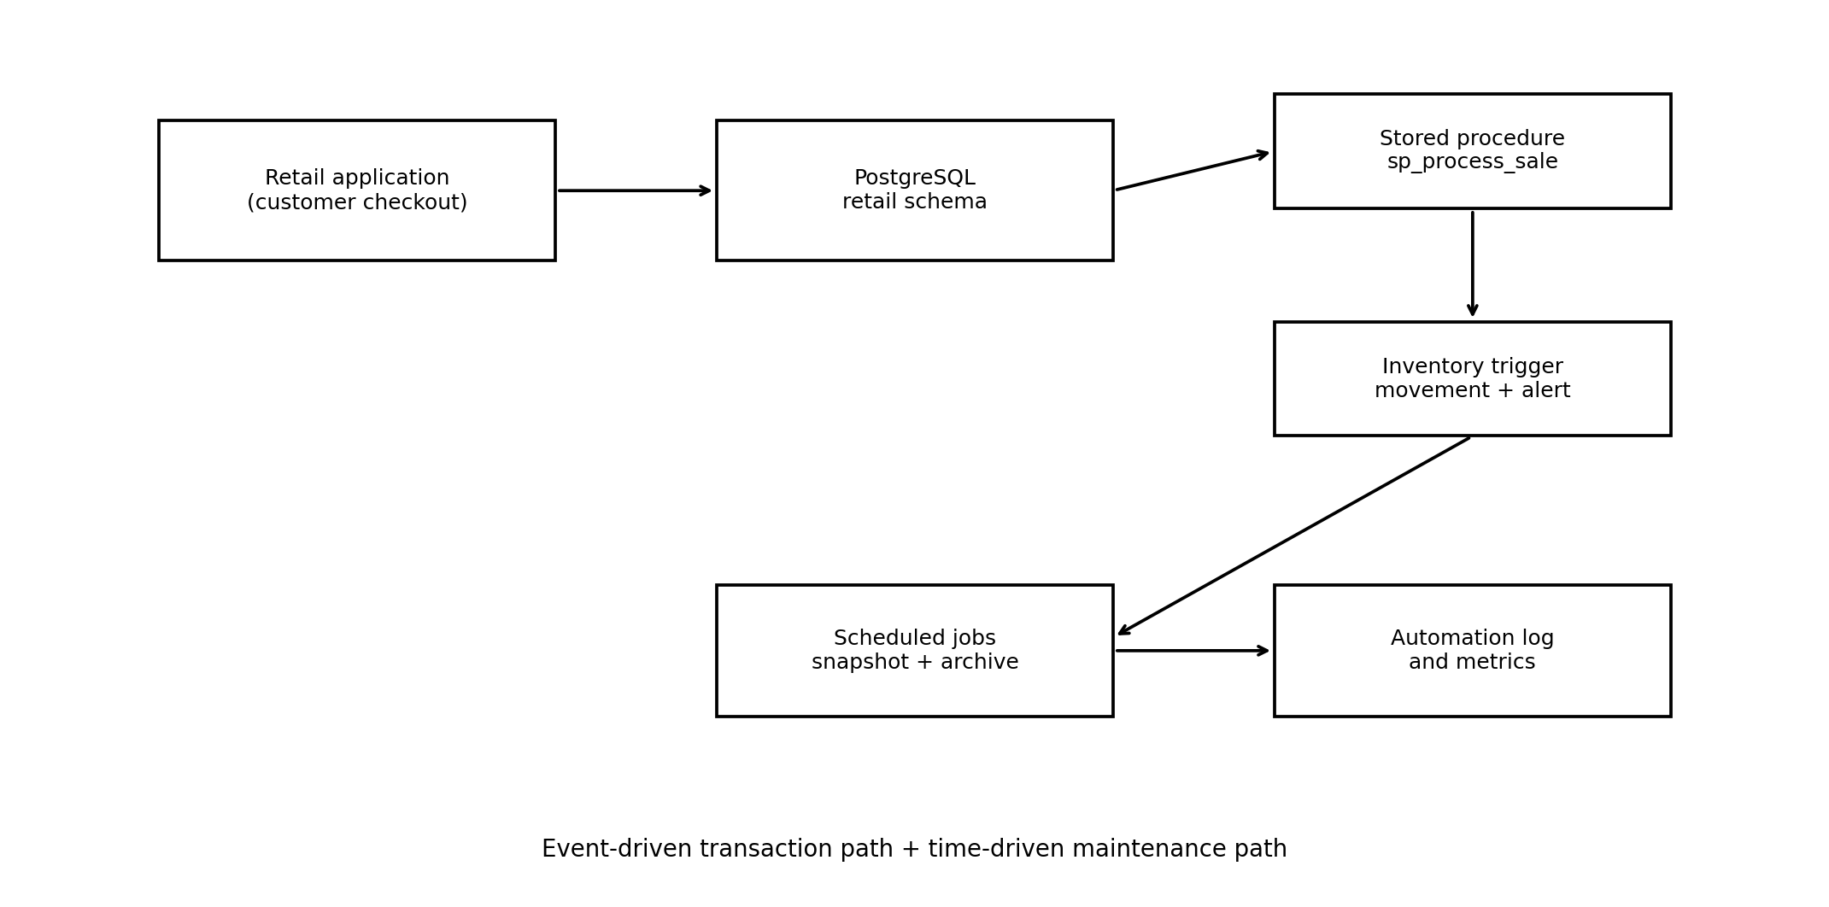
Figure 1. Integration architecture. Checkout invokes the sale procedure. The procedure updates inventory; the trigger reacts within the same transaction. Time-based jobs run independently and write execution outcomes to the automation log.
- Checkout calls sp_process_sale with customer, warehouse, product and quantity.
- The procedure validates inputs and references, reads the active catalog price, then locks the matching inventory row.
- If stock is insufficient, an exception aborts the CALL statement. If sufficient, the procedure inserts an order and order item and deducts stock.
- The AFTER UPDATE trigger writes a movement record and checks the reorder threshold. It creates or updates one open alert, or resolves an alert when stock recovers.
- Scheduled tasks capture daily stock snapshots and copy eligible old orders and order items into archive tables.
- Monitoring queries read automation_log, low_stock_alerts, inventory_movements and the inventory health view.

5. Stored Procedure: Transaction-Safe Sale Processing
The procedure retail.sp_process_sale accepts one customer, warehouse, product and quantity. It uses SELECT ... FOR UPDATE on the inventory row. This serializes competing updates to the same product/warehouse stock record, so two checkouts cannot both rely on the same stale quantity. The procedure stores products.current_price in order_items.unit_price to preserve the transaction-time price.
Error handling uses RAISE EXCEPTION with SQLSTATE codes. PostgreSQL treats an unhandled error in the CALL statement as a failed statement; all changes made by that statement are rolled back. The procedure deliberately does not COMMIT internally, allowing the caller to control the surrounding transaction.
Scenario | Expected result | Reason
Quantity <= 0 | Reject with 22023 | Invalid input must not create an order
Unknown customer/product | Reject with foreign-key style error | Prevent orphan transactions
Missing inventory row | Reject | A warehouse stock record is required
Insufficient quantity | Reject with P0001 | Prevent overselling
Valid sale | Insert order/item and reduce stock | One consistent database operation
Trade-off: row-level locking protects correctness but concurrent checkouts for the same popular SKU may wait. Keep the transaction short, lock only the relevant stock row, and consider reservation records or queue-based allocation at higher scale.

6. Trigger: Movement Audit and Low-Stock Alert
A BEFORE UPDATE trigger stamps updated_at, while the AFTER UPDATE OF quantity_on_hand trigger runs only when the inventory quantity changes. It records before/after quantities and the delta in inventory_movements. If the new quantity is less than or equal to reorder_level, it upserts a single OPEN alert. If stock rises above the threshold, the open alert is resolved with a timestamp.
This centralizes the stock rule regardless of whether inventory is changed by the sale procedure, a replenishment operation or an administrative update. The partial unique index prevents duplicate OPEN alerts for the same product and warehouse. The trigger has a write cost: every stock change adds an audit row and may update an alert. It should remain small, deterministic and free of external network calls.

7. Scheduled Tasks and Archiving
The package includes two scheduled procedures. sp_capture_daily_inventory performs an idempotent upsert for the current date, recording quantity and unit cost by product and warehouse. sp_archive_old_orders copies orders older than the configured retention period and their order_items into archive tables. Unique archive identifiers and ON CONFLICT DO NOTHING make reruns safe.
The archive procedure intentionally does not delete source rows. A production purge must be a separately approved step after legal retention review, row-count reconciliation, backup verification and a tested restore procedure. The optional pg_cron script schedules daily snapshot capture at 00:05 and monthly archive at 02:30 on day one. Confirm server timezone and extension availability. If pg_cron is unavailable, use an OS scheduler or orchestration service to call psql with a protected connection string.
Job | Schedule example | Purpose / control
daily_inventory_snapshot | Every day 00:05 | Upsert daily stock values; log row count
monthly_order_archive | 1st day monthly 02:30 | Copy orders older than 365 days; retain source

8. Inventory Analytics: Turnover and Stock Cover
Inventory turnover measures how many times inventory value is sold and replenished over a period. The implementation uses: Inventory Turnover (30d) = 30-day cost of goods sold / average inventory value over the same period. COGS is quantity sold multiplied by unit_cost; if cost is unavailable, the view falls back to order-item unit_price and the result should be flagged as an approximation.
Stock cover days estimates how long current average stock can support the recent sales rate: Stock Cover Days = average on-hand units / (units sold in the period / number of days). The view uses a 30-day window. A value of 6 days means that, at the recent average sales rate, average stock would cover approximately six more days. It is not a reorder recommendation by itself: lead time, safety stock, seasonality, open purchase orders and demand variability must also be considered.
Metric | Formula | Interpretation / caveat
COGS (30d) | SUM(quantity × unit_cost) | Cost basis, not revenue
Average inventory value | AVG(daily on-hand × unit_cost) | Requires daily snapshots across the period
Turnover (30d) | COGS ÷ average inventory value | Higher is not always better; stockouts may suppress inventory
Stock cover days | Average units ÷ (30-day units sold ÷ 30) | Undefined when no sales; do not report as zero days
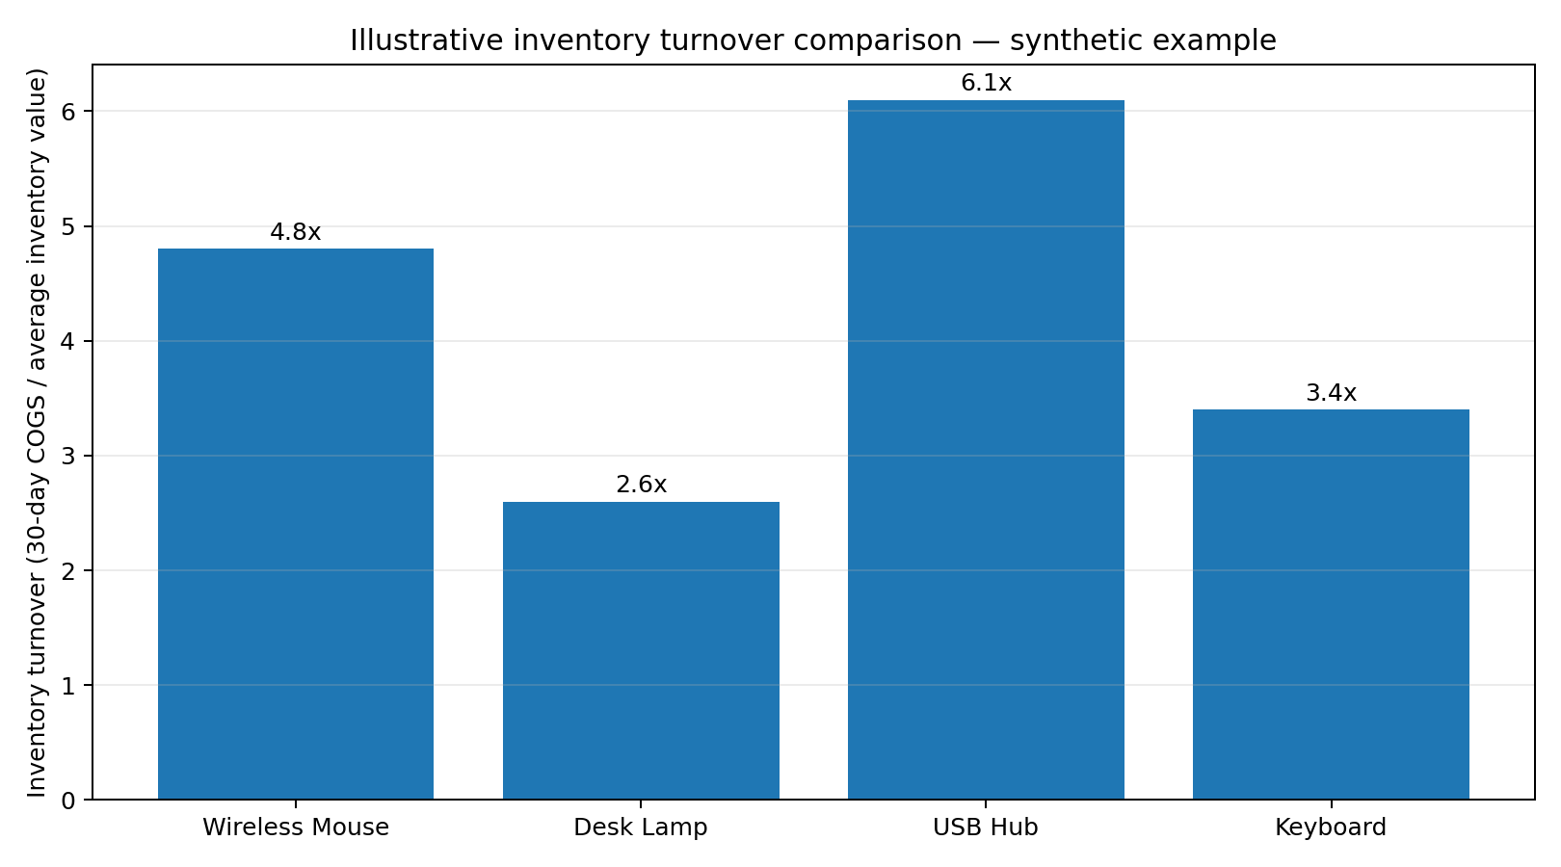
Figure 2. Synthetic illustration only. The bar values are examples to demonstrate how to compare SKUs; they are not query output from the internship database.
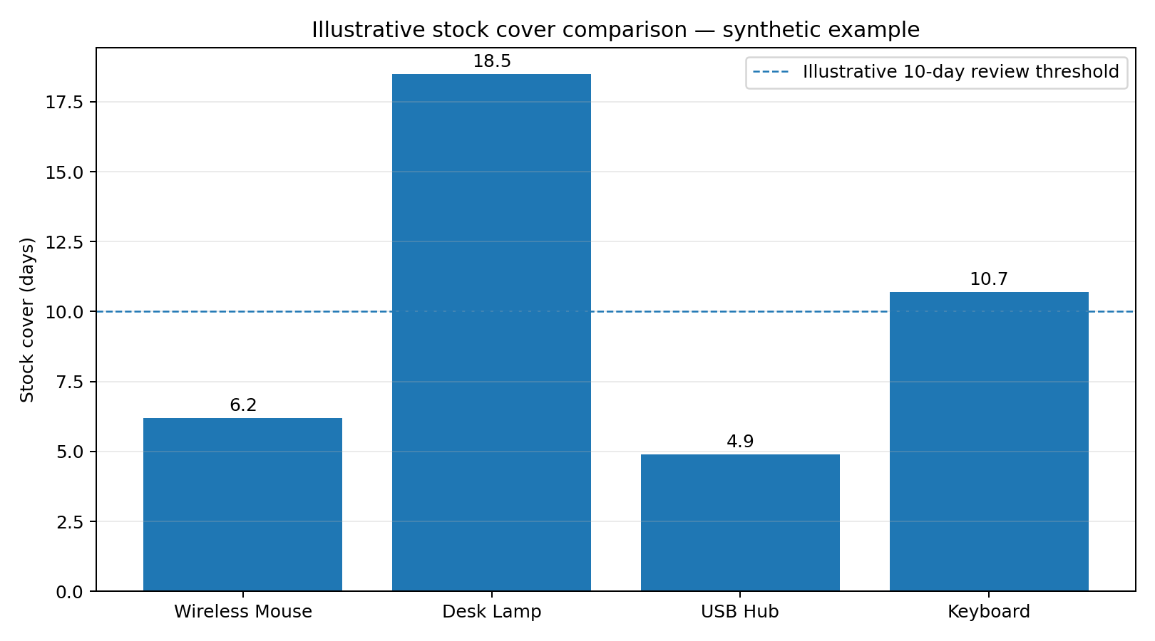
Figure 3. Synthetic illustration only. A low cover value may require replenishment review, while unusually high cover can indicate excess or slow-moving stock. A real dashboard should show the underlying time window, data freshness and replenishment lead time.

9. Testing and Validation
Test | Action | Expected outcome
T01 Valid sale | Sell 1 unit from seeded stock | Order and item inserted; stock decreases by 1
T02 Invalid quantity | Call procedure with 0 or negative quantity | Validation exception; no order
T03 Oversell | Request more than available stock | Exception; no partial order remains
T04 Low-stock threshold | Update stock to <= reorder_level | One OPEN alert is present
T05 Recovery | Raise stock above reorder_level | OPEN alert is resolved
T06 Snapshot rerun | Run snapshot twice same day | One snapshot row per date/product/warehouse
T07 Archive rerun | Run archive repeatedly | No duplicate archive keys; originals retained
sql/07_tests.sql contains executable assertions for valid sale, oversell rejection, low-stock alert creation and alert resolution. It runs inside a transaction and rolls back at the end so test mutations do not persist. sql/06_run_demo.sql is a separate demonstration that creates a sample sale and leaves its result in the training database. Preserve the actual psql output after running scripts; expected outcomes are not the same as observed evidence.
For concurrency validation, open two sessions and attempt sales whose combined quantity exceeds stock. Confirm that the second session waits for the row lock and then fails after the first commits if the remaining stock is insufficient. Capture the actual SQL and timestamps in the execution log.

10. Error Handling, Security and Reliability
- Validate quantities and entity references before writes; retain CHECK, primary-key and foreign-key constraints as a second integrity layer.
- Use parameterized calls from the application; never concatenate user values into dynamic SQL.
- Grant application roles only required EXECUTE and SELECT/INSERT/UPDATE permissions. Do not grant superuser or schema-owner privileges to the application.
- Keep credentials outside GitHub (environment variables or a secret manager); use TLS for remote connections.
- Log process name, start/finish time, status, processed rows and sanitized error text. Do not log payment secrets or unnecessary personal data.
- Monitor failed jobs, long-running transactions, lock waits, alert backlog and snapshot freshness.
- Back up before migrations and test restore procedures. A backup that has never been restored is unverified.

11. Performance and Design Trade-offs
Design choice | Benefit | Cost / mitigation
FOR UPDATE inventory lock | Prevents stale-stock overselling | Can queue same-SKU checkouts; keep transactions short
AFTER UPDATE trigger | Consistent alerting across writers | Adds write latency; keep trigger bounded
Partial unique alert index | At most one OPEN alert per SKU/location | Index maintenance on alert status changes
Daily inventory snapshot | Enables defensible average stock metrics | Storage and scheduled write overhead; partition at scale
Copy-only archive | Safe reruns and reversible retention workflow | Storage remains duplicated until approved purge
Selective indexes | Faster joins and filters | Write/storage overhead; verify with EXPLAIN ANALYZE

12. Limitations and Future Improvements
- Add a full stock-movement model for receipts, returns, reservations, transfers and adjustments instead of relying only on current balances.
- Add supplier lead times, safety-stock calculations and purchase-order automation; trigger reorder suggestions using forecast demand rather than a static threshold.
- Use a separate idempotency key for externally retried checkout requests so network retries cannot create duplicate sales.
- Add multi-item sale support with deterministic product-row lock ordering to reduce deadlocks.
- Partition high-volume movement, snapshot and archive tables by month after workload evidence justifies it.
- Integrate alerts with email, messaging or ticketing through an asynchronous outbox; avoid external API calls inside database triggers.
- Add job retry/backoff, dead-letter handling and a dashboard for job duration, failures, stock cover and alert age.
- Replace the sample scheduler with managed orchestration where deployments span multiple databases or dependencies.

13. Conclusion
The Week 5 design connects transaction processing, event-driven triggers and time-based scheduling into one retail workflow. The stored procedure protects sale consistency and stock availability, the trigger automates stock audit and low-stock alerts, and scheduled jobs maintain historical snapshots and archive copies. The metrics view makes inventory turnover and stock cover definitions explicit. The package is designed for repeatable execution, but its final evidence must come from running the SQL against the actual PostgreSQL environment and recording the real outputs.

Appendix A. File and Execution Guide
Run scripts in this order: 00_bootstrap_retail.sql, 01_automation_support_tables.sql, 02_triggers.sql, 03_stored_procedures.sql, 04_metrics_and_reporting.sql, 05_seed_demo_data.sql, 06_run_demo.sql, 07_tests.sql. Use scripts/run_all.sh or scripts/run_all.ps1 to automate the sequence. Apply 08_schedule_pg_cron.sql only after confirming pg_cron is installed and authorized.
After execution, capture PostgreSQL version, command output, row counts, job configuration, and any EXPLAIN (ANALYZE, BUFFERS) output in tests/execution_log.txt. Add screenshots from your own database client. Do not submit synthetic charts as measured results.

Appendix B. References
- PostgreSQL Documentation — PL/pgSQL: https://www.postgresql.org/docs/current/plpgsql.html
- PostgreSQL Documentation — Explicit Locking: https://www.postgresql.org/docs/current/explicit-locking.html
- PostgreSQL Documentation — CREATE TRIGGER: https://www.postgresql.org/docs/current/sql-createtrigger.html
- PostgreSQL Documentation — CREATE PROCEDURE: https://www.postgresql.org/docs/current/sql-createprocedure.html
- PostgreSQL Documentation — pg_cron (project documentation): https://github.com/citusdata/pg_cron
- Earlier internship project artifact: Virtual Retail Database Design / Data Modeling and Architecture Design (Weeks 1–2).

